WEEK 4

SESSION 1 : Constraint-Driven Solution Design

TASK 1: Determine if string Halves are Alike

Program:
class Solution {
public boolean halvesAreAlike(String s) {
int mid = s.length() / 2;
int countA = 0;
int countB = 0;

for (int i = 0; i < mid; i++) {
if (isVowel(s.charAt(i))) {
countA++;
}
}

for (int i = mid; i < s.length(); i++) {
if (isVowel(s.charAt(i))) {
countB++;
}
}

return countA == countB;
}

public boolean isVowel(char ch) {
return ch == 'a' || ch == 'e' || ch == 'i' || ch == 'o' || ch == 'u'
|| ch == 'A' || ch == 'E' || ch == 'I' || ch == 'O' || ch == 'U';
}
}

Output:
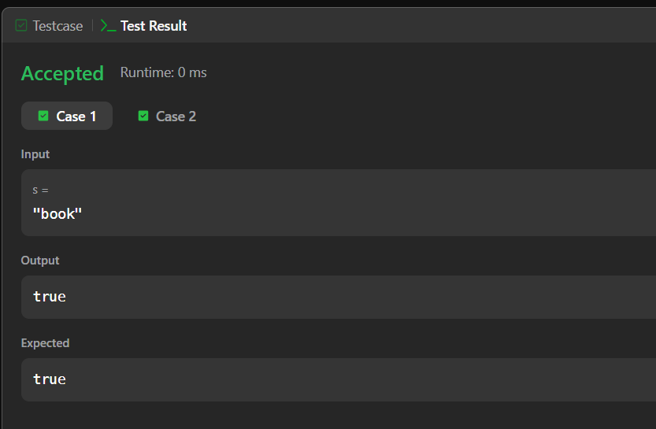

TASK 2: Lapindromes

Program :
import java.util.*;

class Main {
public static void main(String[] args) {
Scanner sc = new Scanner(System.in);

int T = sc.nextInt();

while (T-- > 0) {
String s = sc.next();

int n = s.length();
int mid = n / 2;

int[] left = new int[26];
int[] right = new int[26];

// First half
for (int i = 0; i < mid; i++) {
left[s.charAt(i) - 'a']++;
}

// Second half
for (int i = (n + 1) / 2; i < n; i++) {
right[s.charAt(i) - 'a']++;
}

if (Arrays.equals(left, right)) {
System.out.println("YES");
} else {
System.out.println("NO");
}
}

sc.close();
}
}

Output :
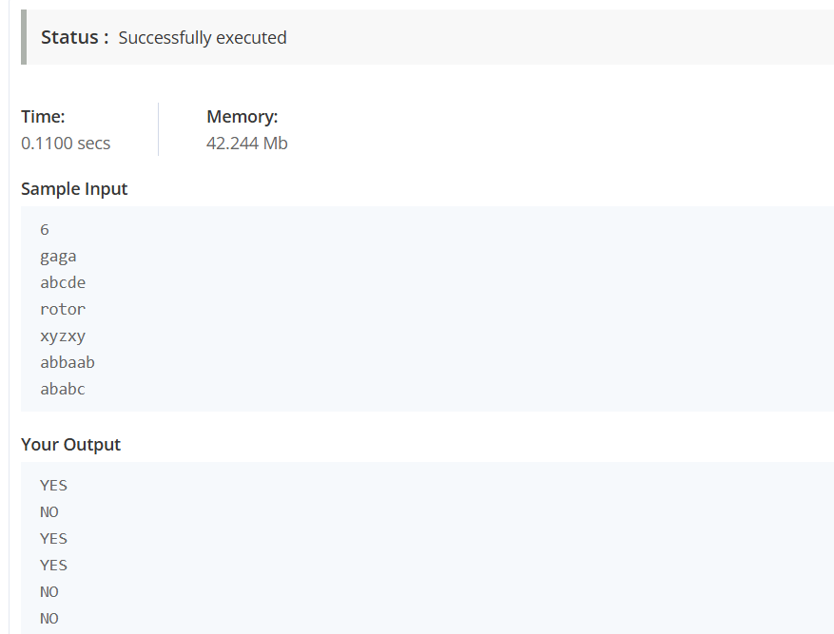

SESSION 2 : Competitive Problem Patterns

Task 3:

Program:
import java.util.*;

class Solution {

public static void main(String[] args) {
Scanner sc = new Scanner(System.in);

int[] a = new int[3];
int[] b = new int[3];

for (int i = 0; i < 3; i++) {
a[i] = sc.nextInt();
}

for (int i = 0; i < 3; i++) {
b[i] = sc.nextInt();
}

int alice = 0;
int bob = 0;

for (int i = 0; i < 3; i++) {
if (a[i] > b[i]) {
alice++;
} else if (a[i] < b[i]) {
bob++;
}
}

System.out.println(alice + " " + bob);

sc.close();
}
}

Output:
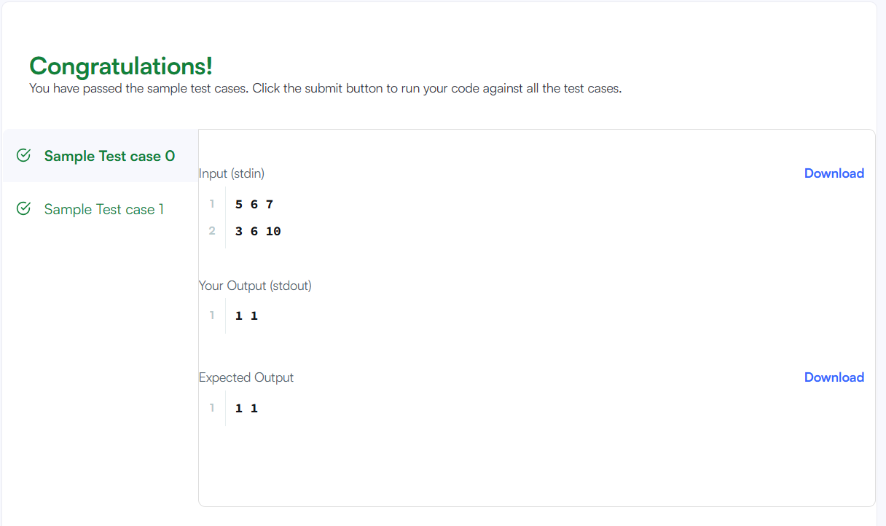

TASK 4: Conatains Duplicates

Program :
import java.util.*;

class Solution {
public boolean containsDuplicate(int[] nums) {

HashSet<Integer> set = new HashSet<>();

for (int num : nums) {

if (set.contains(num)) {
return true;
}

set.add(num);
}

return false;
}
}

Output :
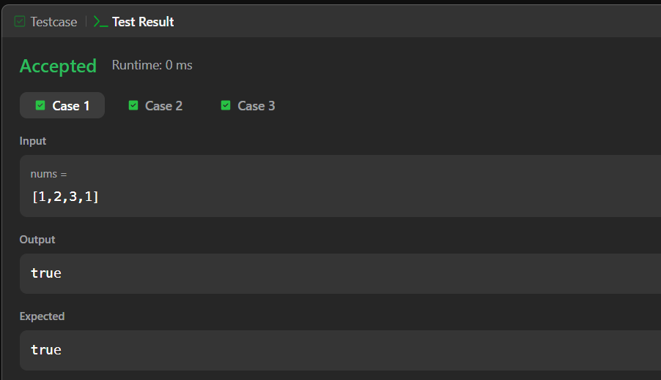

SESSION 3: Writing Efficient Code

Task 5: Time Conversion

Program:
import java.util.*;

class Result {

public static String timeConversion(String s) {

int hour = Integer.parseInt(s.substring(0, 2));
String ampm = s.substring(8, 10);

if (ampm.equals("AM")) {
if (hour == 12) {
hour = 0;
}
} else {
if (hour != 12) {
hour = hour + 12;
}
}

return String.format("%02d", hour) + s.substring(2, 8);
}
}

public class Solution {

public static void main(String[] args) {
Scanner sc = new Scanner(System.in);

String s = sc.next();

System.out.println(Result.timeConversion(s));

sc.close();
}
}

Output :
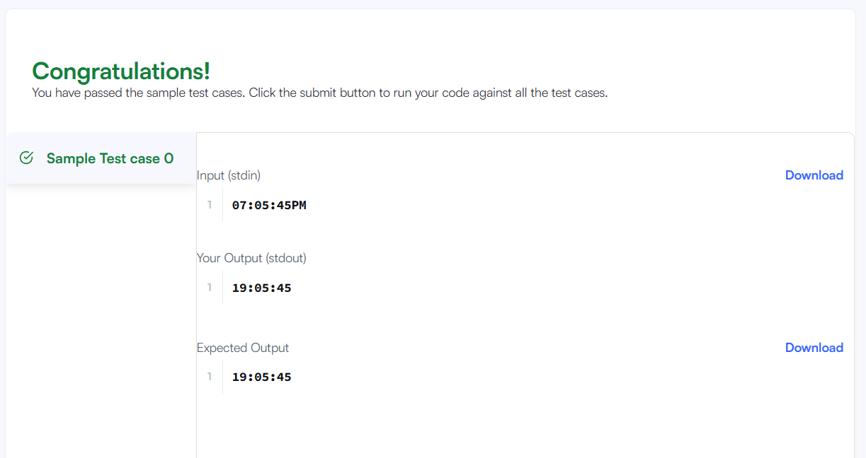

TASK 6 : Move Zeroes

Program :
class Solution {
public void moveZeroes(int[] nums) {
int index = 0;

// Move all non-zero elements to the front
for (int i = 0; i < nums.length; i++) {
if (nums[i] != 0) {
nums[index] = nums[i];
index++;
}
}

// Fill the remaining positions with zeros
while (index < nums.length) {
nums[index] = 0;
index++;
}
}
}

Output :
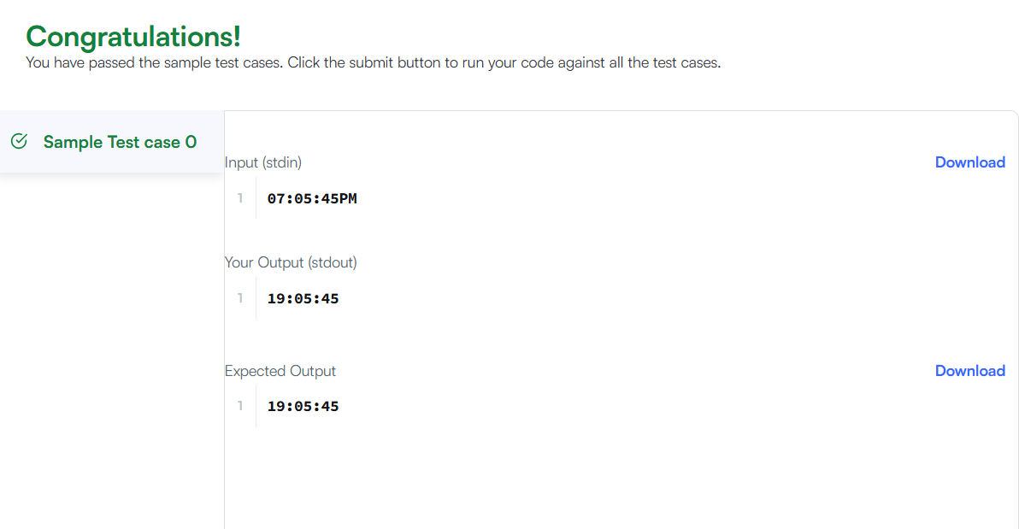

SESSION 3: Writing Efficient Code

Task 7: Diagonal Difference

Program:
import java.util.*;

class Result {

public static int diagonalDifference(List<List<Integer>> arr) {

int n = arr.size();

int leftSum = 0;
int rightSum = 0;

for (int i = 0; i < n; i++) {

// Left-to-right diagonal
leftSum += arr.get(i).get(i);

// Right-to-left diagonal
rightSum += arr.get(i).get(n - 1 - i);
}

return Math.abs(leftSum - rightSum);
}
}

public class Solution {

public static void main(String[] args) {

Scanner sc = new Scanner(System.in);

int n = sc.nextInt();

List<List<Integer>> arr = new ArrayList<>();

for (int i = 0; i < n; i++) {

List<Integer> row = new ArrayList<>();

for (int j = 0; j < n; j++) {
row.add(sc.nextInt());
}

arr.add(row);
}

System.out.println(Result.diagonalDifference(arr));

sc.close();
}
}

Output :
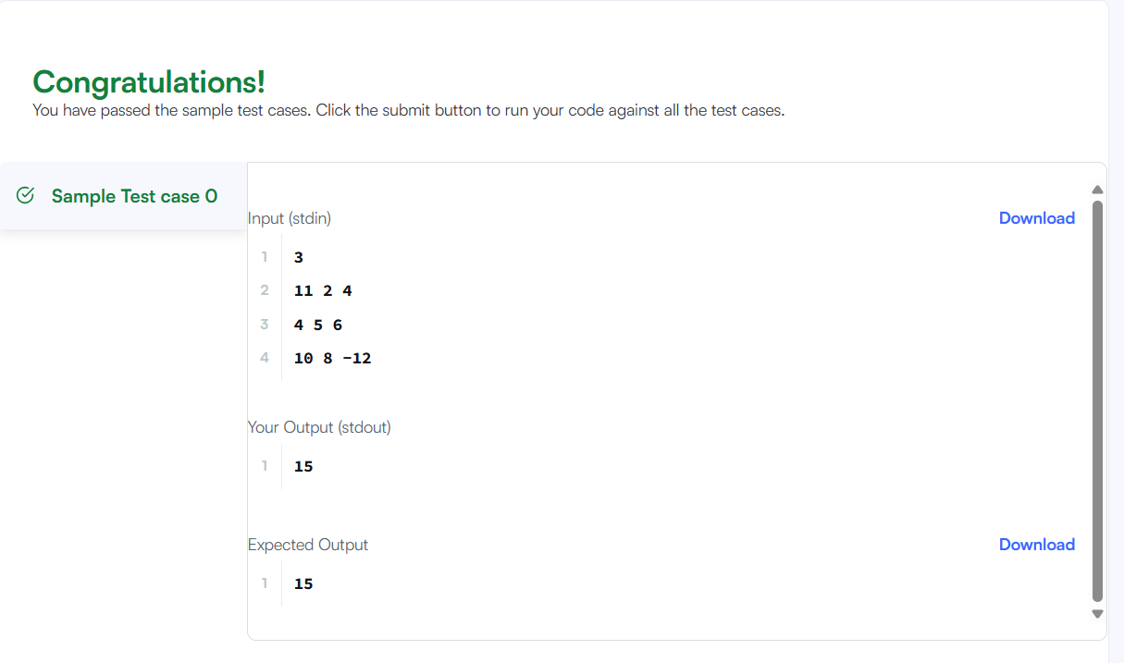

TASK 8: Transpose Matrix

Program:
class Solution {
public int[][] transpose(int[][] matrix) {

int m = matrix.length;
int n = matrix[0].length;

int[][] result = new int[n][m];

for (int i = 0; i < m; i++) {
for (int j = 0; j < n; j++) {
result[j][i] = matrix[i][j];
}
}

return result;
}
}

Output :
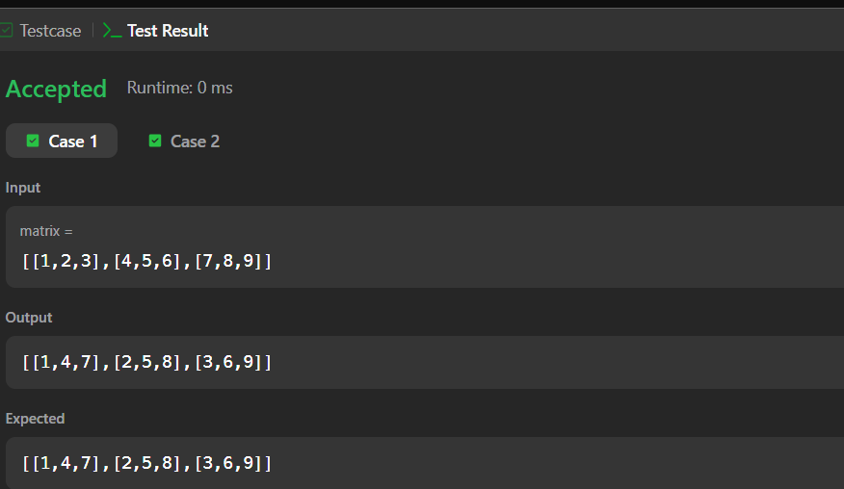

SESSION 5: Strassen’s Matrix Multiplication:

TASK 9: Matrix block sum

Program:
class Solution {
public int[][] matrixBlockSum(int[][] mat, int k) {

int m = mat.length;
int n = mat[0].length;

int[][] answer = new int[m][n];

for (int i = 0; i < m; i++) {
for (int j = 0; j < n; j++) {

int sum = 0;

int startRow = Math.max(0, i - k);
int endRow = Math.min(m - 1, i + k);

int startCol = Math.max(0, j - k);
int endCol = Math.min(n - 1, j + k);

for (int r = startRow; r <= endRow; r++) {
for (int c = startCol; c <= endCol; c++) {
sum += mat[r][c];
}
}

answer[i][j] = sum;
}
}

return answer;
}
}

Output:
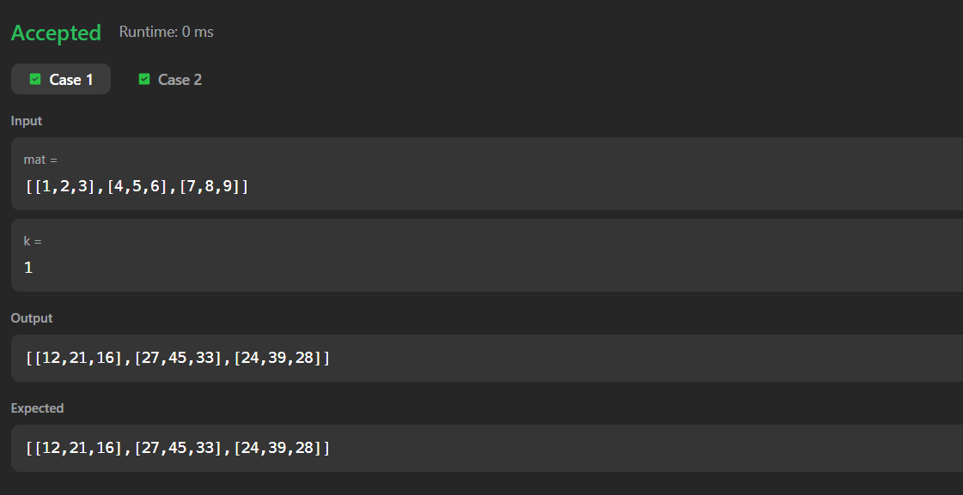

TASK 10: Matrix rotation

Program :
import java.util.*;

class Result {

public static void matrixRotation(List<List<Integer>> matrix, int r) {

int m = matrix.size();
int n = matrix.get(0).size();

int[][] arr = new int[m][n];

// Convert List<List<Integer>> to 2D array
for (int i = 0; i < m; i++) {
for (int j = 0; j < n; j++) {
arr[i][j] = matrix.get(i).get(j);
}
}

// Number of layers
int layers = Math.min(m, n) / 2;

for (int layer = 0; layer < layers; layer++) {

List<Integer> values = new ArrayList<>();

int top = layer;
int left = layer;
int bottom = m - 1 - layer;
int right = n - 1 - layer;

// Top row: left -> right
for (int j = left; j <= right; j++) {
values.add(arr[top][j]);
}

// Right column: top+1 -> bottom
for (int i = top + 1; i <= bottom; i++) {
values.add(arr[i][right]);
}

// Bottom row: right-1 -> left
for (int j = right - 1; j >= left; j--) {
values.add(arr[bottom][j]);
}

// Left column: bottom-1 -> top+1
for (int i = bottom - 1; i > top; i--) {
values.add(arr[i][left]);
}

int len = values.size();
int shift = r % len;

// Put rotated values back
int index = shift;

// Top row
for (int j = left; j <= right; j++) {
arr[top][j] = values.get(index);
index = (index + 1) % len;
}

// Right column
for (int i = top + 1; i <= bottom; i++) {
arr[i][right] = values.get(index);
index = (index + 1) % len;
}

// Bottom row
for (int j = right - 1; j >= left; j--) {
arr[bottom][j] = values.get(index);
index = (index + 1) % len;
}

// Left column
for (int i = bottom - 1; i > top; i--) {
arr[i][left] = values.get(index);
index = (index + 1) % len;
}
}

// Print result
for (int i = 0; i < m; i++) {
for (int j = 0; j < n; j++) {
System.out.print(arr[i][j]);

if (j < n - 1) {
System.out.print(" ");
}
}
System.out.println();
}
}
}

public class Solution {

public static void main(String[] args) {

Scanner sc = new Scanner(System.in);

int m = sc.nextInt();
int n = sc.nextInt();
int r = sc.nextInt();

List<List<Integer>> matrix = new ArrayList<>();

for (int i = 0; i < m; i++) {

List<Integer> row = new ArrayList<>();

for (int j = 0; j < n; j++) {
row.add(sc.nextInt());
}

matrix.add(row);
}

Result.matrixRotation(matrix, r);

sc.close();
}
}

Output:
